**Index.html**

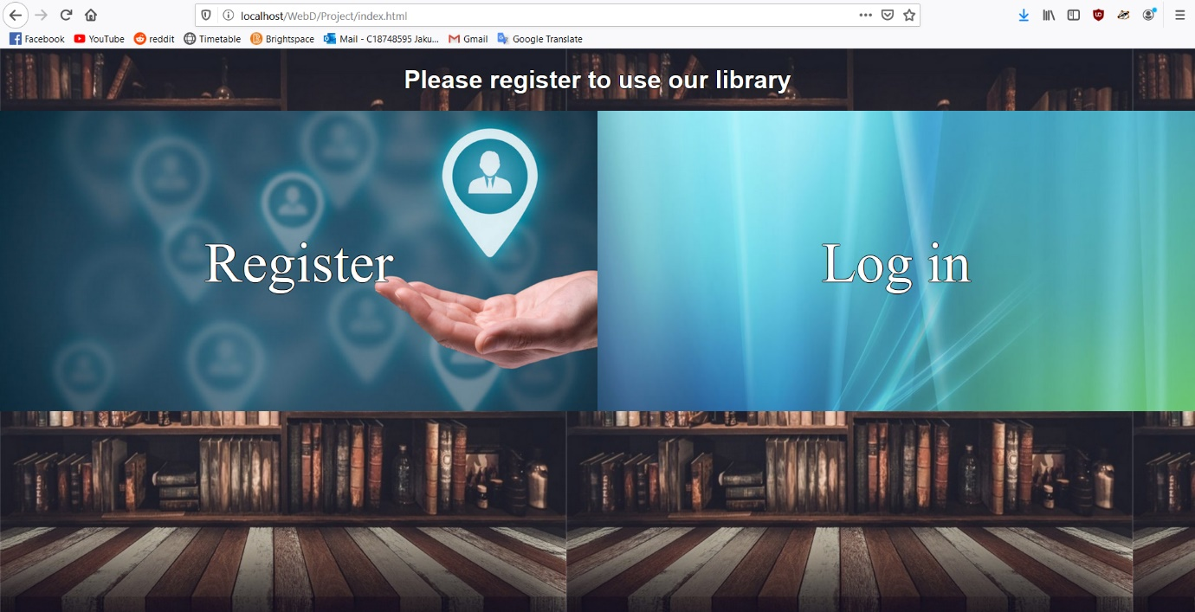

**Description:**

* This page just contains two links for users, either to go and register or log in to the home page.

**Code:**

**<!DOCTYPE html>**

**<html>**

**<head>**

**<meta charset="utf-8">**

**<link rel="stylesheet" type="text/css" href="site.css">**

**<meta name="viewport" content="width=device-width, initial-scale=1">**

**<title>Welcome</title>**

**</head>**

**<body id="registration_page">**

**<h1 id="registration_h1">Please register to use our library</h1>**

**<div class="half_screen_div01">**

**<a id="login_link" href="login.html">Log in</a>**

**</div><div class="half_screen_div02"><a id="registation_link" href="registration.html">Register</a></div>**

**</body>**

**</html>**

**Register.html**

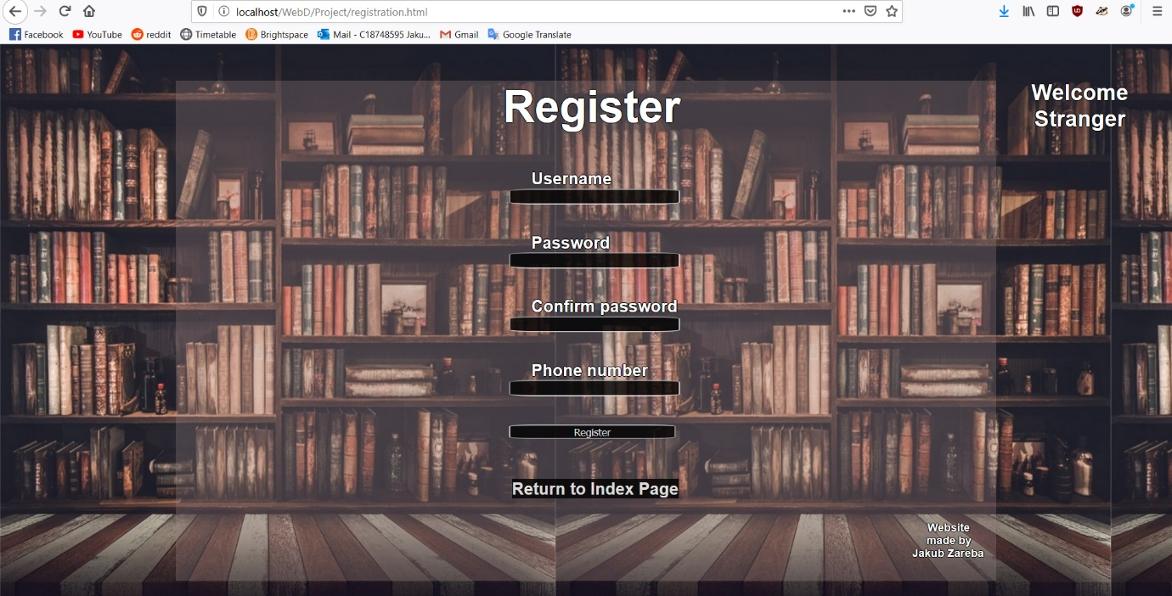

**Description:**

* This page displays to the user a simple form that offers user to create an account in the library system. It contains few input fields and submit button that sends data entered by the user to appropriate php scripts that perform queries on the data and returns back results, on which depends if user account creation went smoothly. If not, data won’t be added to the data base and appropriate error will be displayed to the user.

**Code:**

**<!DOCTYPE html>**

**<html>**

**<head>**

**<meta charset="utf-8">**

**<link rel="stylesheet" type="text/css" href="site.css">**

**<meta name="viewport" content="width=device-width, initial-scale=1">**

**<title>Registration Page</title>**

**</head>**

**<body id="registration_page">**

**<div id="header">**

**<p>Welcome<br>Stranger</p>**

**</div>**

**<div id="main">**

**<h2>Register</h2>**

**<form action="registration.php" method="post">**

**<label>Username</label><input type="text" name="UserName">**

**<br><br>**

**<label>Password</label><input type="text" name="Password01">**

**<br><br>**

**<label>Confirm password</label><input type="text" name="Password02">**

**<br><br>**

**<label>Phone number</label><input type="text" name="PhoneNo">**

**<br><br>**

**<input type="submit" name="register" value="Register">**

**</form>**

**<p><a id="return_link" href="index.html">Return to Index Page</a></p>**

**<div id="footer">**

**<p>Website<br id="br01">made by<br id="br02">Jakub Zareba<br id="br03"></p>**

**</div>**

**</div>**

**</body>**

**</html>**

**Login.html**

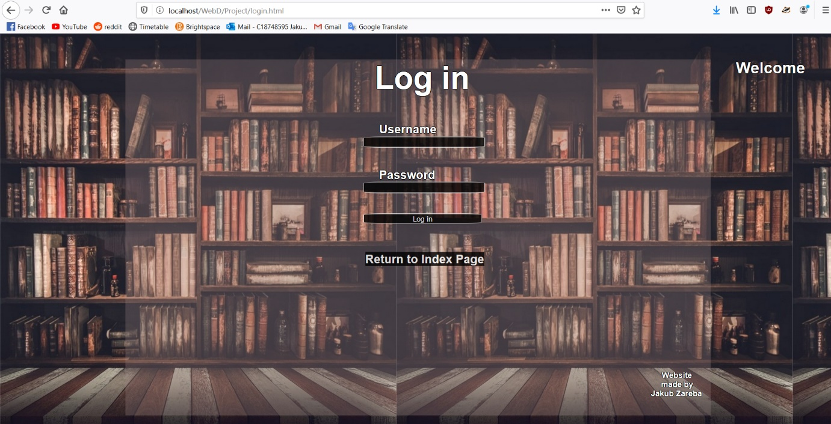

**Description:**

* The page is similar to registration.html. All it offers is few input fields that will carry user data to php scripts and a submit button. It also contains a return link back to the index page.

**Code:**

**<!DOCTYPE html>**

**<html>**

**<head>**

**<meta charset="utf-8">**

**<link rel="stylesheet" type="text/css" href="site.css">**

**<meta name="viewport" content="width=device-width, initial-scale=1">**

**<title>Login page</title>**

**</head>**

**<body id="registration_page">**

**<div id="header">**

**<p>Welcome</p>**

**</div>**

**<div id="main">**

**<h2>Log in</h2>**

**<form action="login.php" method="post">**

**<label>Username</label><input type="text" name="UserName">**

**<br><br>**

**<label>Password</label><input type="text" name="Password">**

**<br><br>**

**<input type="submit" name="login" value="Log in">**

**</form>**

**<p><a id="return_link" href="index.html">Return to Index Page</a></p>**

**<div id="spacer"></div>**

**<div id="footer">**

**<p>Website<br id="br01">made by<br id="br02">Jakub Zareba<br id="br03"></p>**

**</div>**

**</div>**

**</body>**

**</html>**

**Home.php**

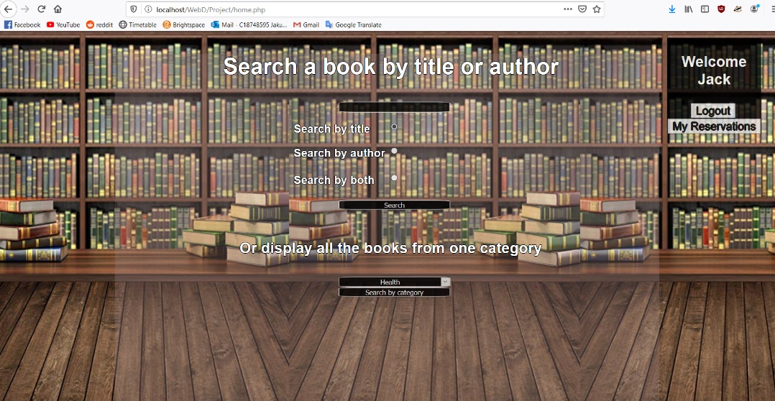

**Description:**

* Home.php is a mixture of php and html in order to present an average looking interface to the user. It contains radio buttons that allow the user to select appropriate searching method and enter a book title or author’s name. Also, a drop down menu with category selection that will display all the books from given category to the user. This is the first page on which header displays the username that was assigned during the logging in process to a session variable. Also within the header, under the username, a logout button and reservation button are present. First one, logs out the user and destroys the session so the variables can be reused in a later session by the next user. After data is entered by the user it’s being carried to appropriate scripts.

**Code:**

**<?php**

**session_start();**

**require_once "connection.php";**

**if(!isset($_SESSION['username'])) {**

**unset($_SESSION['username']);**

**$info = array();**

**array_push($info, "You need to log in first");**

**$_SESSION['errors'] = $info;**

**$_SESSION['logout'] = "Logging out";**

**header("refresh:0; url=print_errors.php");**

**}**

**?>**

**<!DOCTYPE html>**

**<html>**

**<head>**

**<meta charset="utf-8">**

**<link rel="stylesheet" type="text/css" href="site.css">**

**<meta name="viewport" content="width=device-width, initial-scale=1">**

**<title>Home Page</title>**

**</head>**

**<body id="home_page">**

**<div id="header2">**

**<p>Welcome<br><?php echo $_SESSION['username']; ?></p>**

**<form action="logout.php" method="post">**

**<input id="logout_button" type="submit" value="Logout" name="logout"><br>**

**<input id="my_reservations_button" type="submit" value="My Reservations" name="display_reservations">**

**</form>**

**</div>**

**<div id="main02">**

**<h3>Search a book by title or author</h3>**

**<form action="user_search.php" method="post">**

**<input type="text" name="userSearch"><br>**

**<input type="radio" name="search" value="Search by title" checked><span>Search by title</span><br>**

**<input style="margin-top: 1.5%;" type="radio" name="search" value="Search by author"><span>Search by author</span><br><br>**

**<input type="radio" name="search" value="Search by both"><span>Search by both</span><br><br>**

**<input type="submit" value="Search">**

**</form><br>**

**<h4>Or display all the books from one category</h4>**

**<form action="category_list.php" method="post">**

**<select name="category">**

**<option value="1">Health</option>**

**<option value="2">Business</option>**

**<option value="3">Biography</option>**

**<option value="4">Technology</option>**

**<option value="5">Travel</option>**

**<option value="6">Self-Help</option>**

**<option value="7">Cookery</option>**

**<option value="8">Fiction</option>**

**</select>**

**<input type="submit" name="category_submit" value="Search by category">**

**</form>**

**<div id="home_page_spacer"></div>**

**<div id="footer">**

**<p>Website<br id="br01">made by<br id="br02">Jakub Zareba<br id="br03"></p>**

**</div>**

**</div>**

**</body>**

**</html>**

**Display_search_results.php**

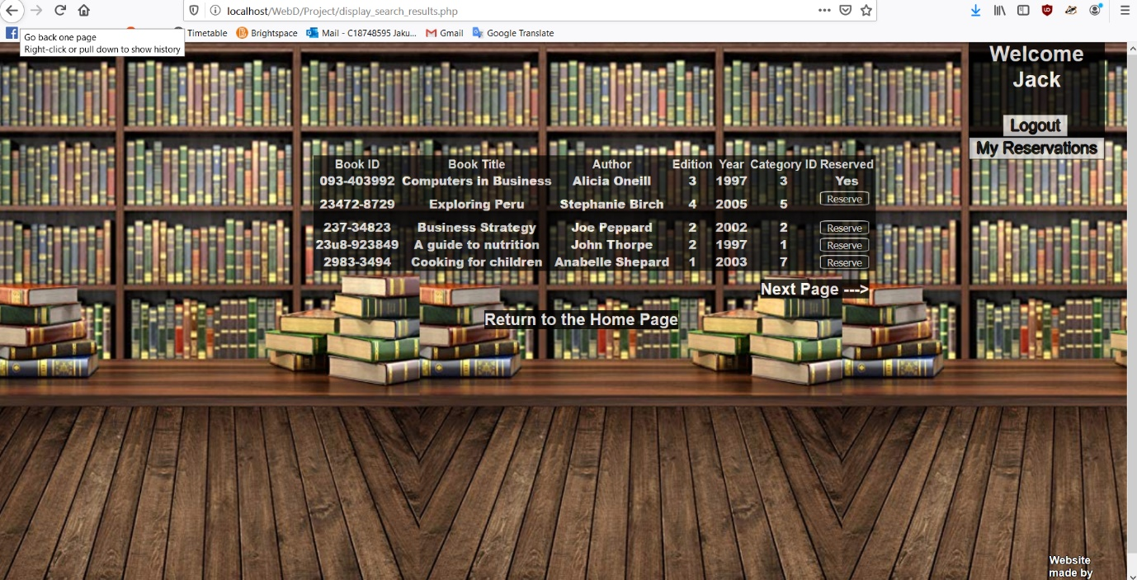

**Description:**

* This is the page that will receive query data from every script on the website in order to print it nicely in a table. As book records are stored in a form of 2D arrays, the script contains a nested for loop that prints out table which contains the data that was sent by another script. As we were asked to display data only 5 elements per page, it also contains a simple algorithm that calculates the variables which are used as a loop boundaries specifiers
* There are 3 buttons placed under the freshly printed table. Each button contains a link that will take user to appropriate place on the website and will perform desired by the user action. First is the return link, which takes user back to the home page. Next two are previous and next page links. They have implemented error checking, so that if you are viewing the first 5 elements and you don’t have any previous elements yet, the button will not be displayed. Same with next page button.

**Code:**

**<?php**

**session_start();**

**require_once "connection.php";**

**if(!isset($_SESSION['username'])) {**

**unset($_SESSION['username']);**

**$info = array();**

**array_push($info, "You need to log in first");**

**$_SESSION['errors'] = $info;**

**$_SESSION['logout'] = "Logging out";**

**header("refresh:0; url=print_errors.php");**

**}**

**?>**

**<!DOCTYPE html>**

**<html>**

**<head>**

**<meta charset="utf-8">**

**<link rel="stylesheet" type="text/css" href="site.css">**

**<meta name="viewport" content="width=device-width, initial-scale=1">**

**<title>Search Results</title>**

**</head>**

**<body id="home_page">**

**<div id="header2">**

**<p>Welcome<br><?php echo $_SESSION['username']; ?></p>**

**<form action="logout.php" method="post">**

**<input id="logout_button" type="submit" value="Logout" name="logout"><br>**

**<input id="my_reservations_button" type="submit" value="My Reservations" name="display_reservations">**

**</form>**

**</div>**

**<?php**

**if($_SESSION['lock'] == "I am set") {**

**echo '<table id="printTable">';**

**echo '<tr>';**

**echo '<td>Book ID</td>';**

**echo '<td>Username</td>';**

**echo '<td>Date</td>';**

**echo '<td>Reserved</td>';**

**echo '</tr>';**

**for($i = 0; $i < count($_SESSION['book_list_sesh']); $i++) {**

**echo '<tr>';**

**for($j = 0; $j < 4; $j++) {**

**if($j == 3) {**

**echo '<td>';**

**echo '<strong>';**

**echo '<form action="unreserve.php" method="post">**

**<input type="submit" name='.$_SESSION['book_list_sesh'][$i]['0'].' value="Remove Reservation">**

**</form>';**

**echo '</strong>';**

**echo '</td>';**

**} else {**

**echo '<td>';**

**echo '<strong>';**

**echo $_SESSION['book_list_sesh'][$i][$j];**

**echo '</strong>';**

**echo '</td>';**

**}**

**}**

**echo '</tr>';**

**}**

**} else {**

**echo '<table id="printTable">';**

**echo '<tr>';**

**echo '<td>Book ID</td>';**

**echo '<td>Book Title</td>';**

**echo '<td>Author</td>';**

**echo '<td>Edition</td>';**

**echo '<td>Year</td>';**

**echo '<td>Category ID</td>';**

**echo '<td>Reserved</td>';**

**echo '</tr>';**

**$_SESSION['counter'] = count($_SESSION['book_list_sesh']);**

**$loop_end = 5;**

**if($loop_end > $_SESSION['counter']) {**

**$loop_end = $_SESSION['counter'];**

**}**

**for($i = 0; $i < $loop_end; $i++) {**

**echo '<tr>';**

**for($j = 0; $j < 7; $j++) {**

**if($_SESSION['book_list_sesh'][$i][$j] == "No") {**

**echo '<td>';**

**echo '<strong>';**

**echo '<form action="reserve.php" method="post">**

**<input type="submit" name='.$_SESSION['book_list_sesh'][$i]['0'].' value="Reserve">**

**</form';**

**echo '</strong>';**

**echo '</td>';**

**} else {**

**echo '<td>';**

**echo '<strong>';**

**echo $_SESSION['book_list_sesh'][$i][$j];**

**echo '</strong>';**

**echo '</td>';**

**}**

**}**

**echo '</tr>';**

**}**

**}**

**$_SESSION['counter'] = count($_SESSION['book_list_sesh']);**

**$_SESSION['counter2'] = 5;**

**?>**

**</table>**

**<p><a id="return_link2" href="home.php">Return to the Home Page</a>**

**<?php**

**if($_SESSION['counter'] > 5) {**

**echo '</p><p><a class="next_page_button" href="next_page.php">Next Page ---></a></p>';**

**}**

**?>**

**<div id="home_page_spacer"></div>**

**<div id="footer">**

**<p>Website<br id="br01_no_div">made by<br id="br02_no_div">Jakub Zareba<br id="br03_no_div"></p>**

**</div>**

**</body>**

**</html>**

**Next_page.php**

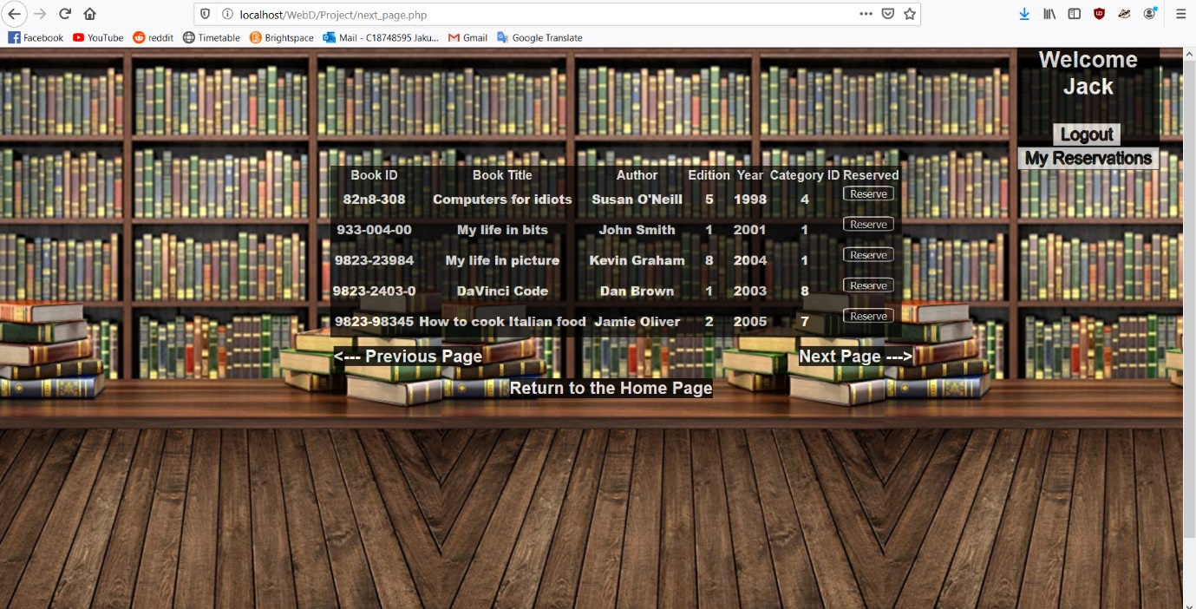

**Description:**

* This script displays the next 5 elements of the search to the user. It again contains simple algorithm that keeps track of which 5 elements should be printed. It again prints table and has 3 links at the bottom of the table that allow user to undertake desired action.

**Code:**

**<?php**

**session_start();**

**require_once "connection.php";**

**if(!isset($_SESSION['username'])) {**

**unset($_SESSION['username']);**

**$info = array();**

**array_push($info, "You need to log in first");**

**$_SESSION['errors'] = $info;**

**$_SESSION['logout'] = "Logging out";**

**header("refresh:0; url=print_errors.php");**

**}**

**?>**

**<!DOCTYPE html>**

**<html>**

**<head>**

**<meta charset="utf-8">**

**<link rel="stylesheet" type="text/css" href="site.css">**

**<meta name="viewport" content="width=device-width, initial-scale=1">**

**<title>Search results</title>**

**</head>**

**<body id="home_page">**

**<div id="header2">**

**<p>Welcome<br><?php echo $_SESSION['username']; ?></p>**

**<form action="logout.php" method="post">**

**<input id="logout_button" type="submit" value="Logout" name="logout"><br>**

**<input id="my_reservations_button" type="submit" value="My Reservations" name="display_reservations">**

**</form>**

**</div>**

**<?php**

**$_SESSION['lock'] = "I am not set";**

**echo '<table id="printTable">';**

**echo '<tr>';**

**echo '<td>Book ID</td>';**

**echo '<td>Book Title</td>';**

**echo '<td>Author</td>';**

**echo '<td>Edition</td>';**

**echo '<td>Year</td>';**

**echo '<td>Category ID</td>';**

**echo '<td>Reserved</td>';**

**echo '</tr>';**

**$x = $_SESSION['counter'] % 5;**

**$a = $_SESSION['counter2'];**

**$loop_end = $a + 5;**

**if($loop_end > $_SESSION['counter'])**

**{**

**$loop_end = $loop_end - 5;**

**$loop_end = $loop_end + $x;**

**}**

**for($i = $a; $i < $loop_end; $i++) {**

**echo '<tr>';**

**for($j = 0; $j < 7; $j++) {**

**if($_SESSION['book_list_sesh'][$i][$j] == "No") {**

**echo '<td>';**

**echo '<strong>';**

**echo '<form action="reserve.php" method="post">**

**<input type="submit" name='.$_SESSION['book_list_sesh'][$i]['0'].' value="Reserve">**

**</form>';**

**echo '</strong>';**

**echo '</td>';**

**} else {**

**echo '<td>';**

**echo '<strong>';**

**echo $_SESSION['book_list_sesh'][$i][$j];**

**echo '</strong>';**

**echo '</td>';**

**}**

**}**

**echo '</tr>';**

**}**

**echo '</table>';**

**$a = $a + 5;**

**$_SESSION['counter2'] = $a;**

**?>**

**<p><a class="previous_page_button" href="previous_page.php"><--- Previous Page</a></p>**

**<p><a id="return_link2" href="home.php">Return to the Home Page</a></p>**

**<?php**

**$b = $_SESSION['counter'] - $loop_end;**

**if($b != 0) {**

**echo '<p><a class="next_page_button" href="next_page.php">Next Page ---></a></p>';**

**}**

**?>**

**<div id="home_page_spacer"></div>**

**<div id="footer">**

**<p>Website<br id="br01_no_div">made by<br id="br02_no_div">Jakub Zareba<br id="br03_no_div"></p>**

**</div>**

**</body>**

**</html>**